**There are 6 print screens each worth 16.6%**

1. Complete the program

**#1 print screen the output with code below here**

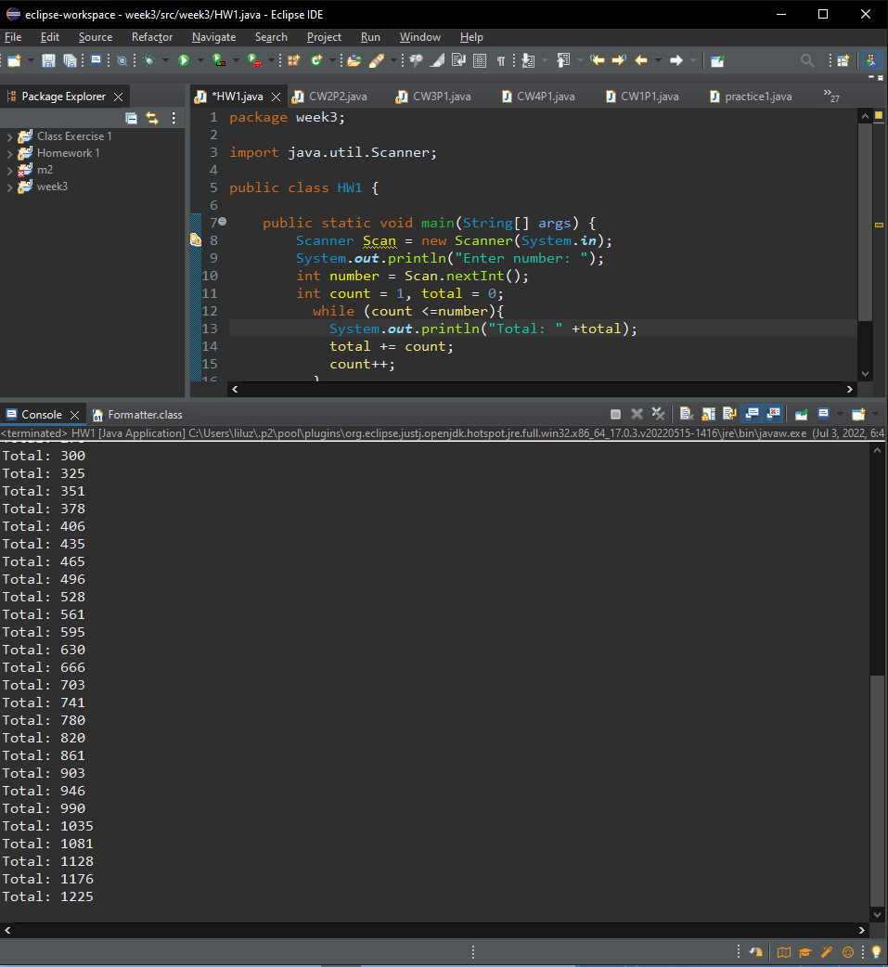

1. Turn to page 258 and complete (find the error) #1, be sure to get the output.

**#2 print screen the output with code below here**

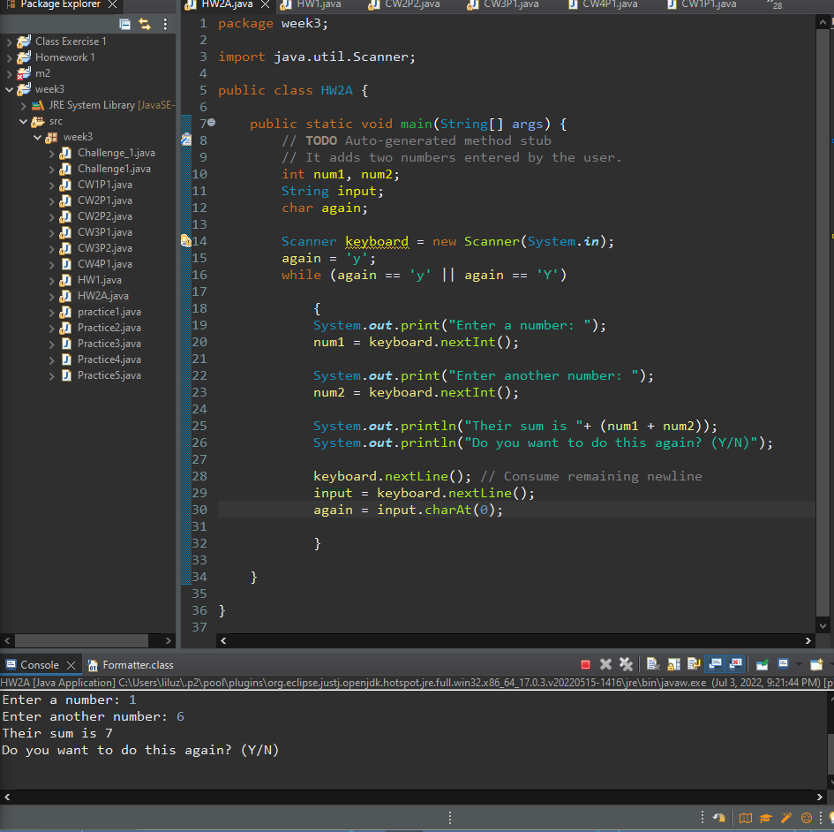

1. Turn to page 259 and complete (find the error) #2, be sure to get an output.

**#3 print screen the output below here**

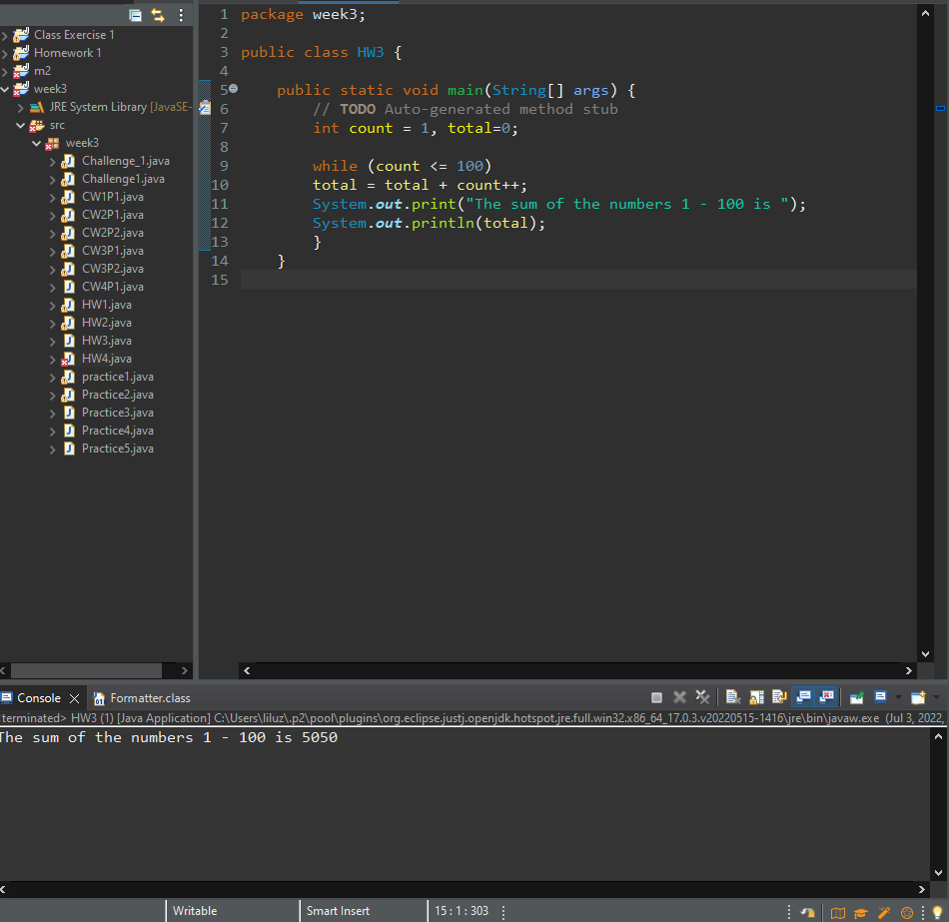

1. Turn to page 259 and complete (find the error) #3, be sure to get an output.

**#4 print screen the output with code below here**

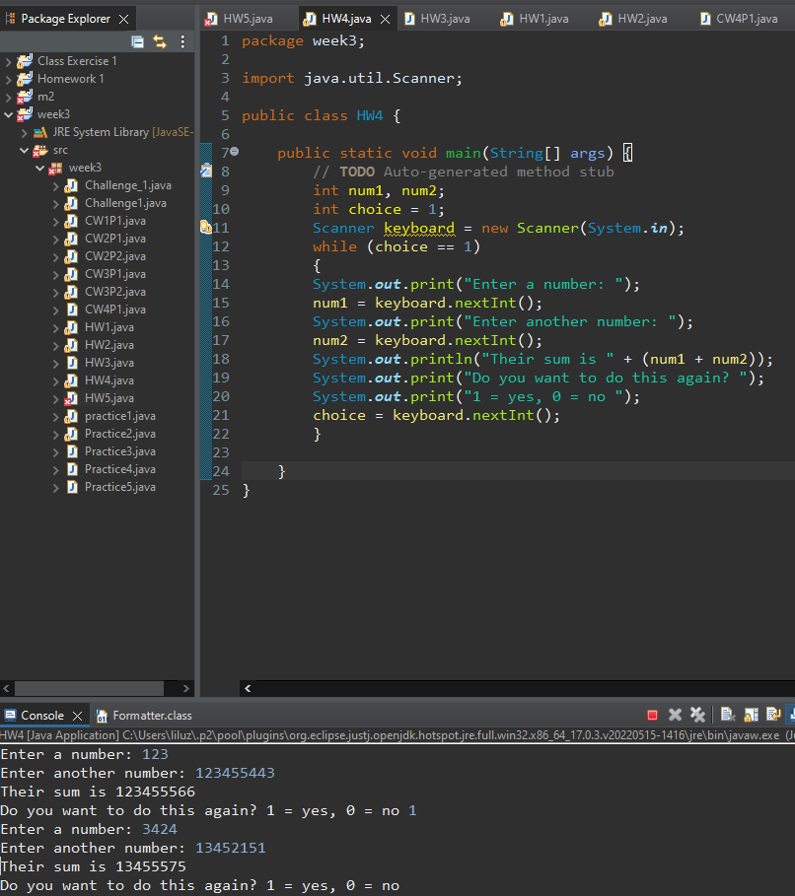

1. Turn to page 259 and complete (find the error) #4, be sure to get an output.

**#5 print screen the output with code below here**

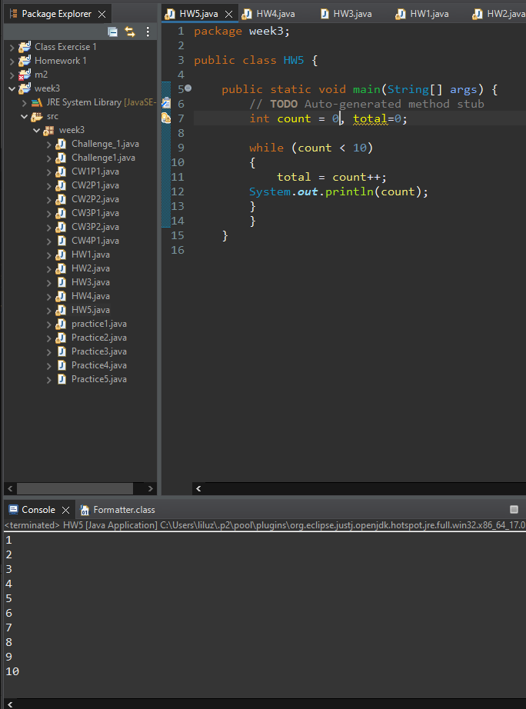

1. Complete the Dice program below

**#6 print screen the output with code below here**

**Submit this document to module 3 homework**